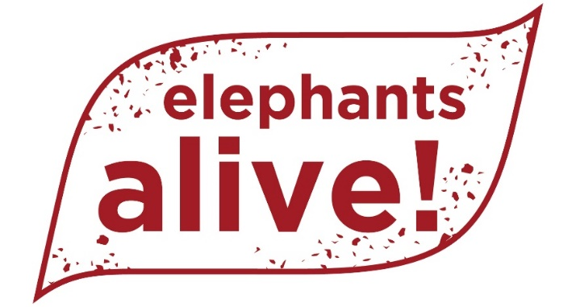

Digital marketing and online fundraising specialist
Freelance / consultancy role
THIS POST CAN BE BASED ANYWHERE IN SOUTH AFRICA AND YOU CAN WORK REMOTELY
Elephants Alive is looking for a digital marketing expert to manage its social media, develop and execute online fundraising appeals, maximise fundraising effectiveness of e-newsletters and update website content.
The ideal candidate will have a deep knowledge of digital marketing and online fundraising fundamentals, the tools needed to support these efforts and a proven track record in successful online fundraising.
This is a part-time, freelance role, there is the potential to be based remotely and you will report to the Development Manager.
Background
For more than 20 years, Elephants Alive has been researching and protecting elephants in the Greater Kruger Area. Our mission is to protect elephants and their habitats and promote harmonious co-existence with people. We are a small but highly impactful and renowned conservation NGO with a team of seven full-time staff, based in Hoedspruit, Limpopo.
We have great stories, fantastic imagery and an enthusiastic social media audience as well as credible scientists who can convey their knowledge.
A new Elephants Alive website is also to be developed, and the installation of a CRM is envisaged.
You will work with the team to identify fundraising and engagement opportunities and produce effective, creative and successful online campaigns and appeals.
Skills Required
A minimum of three years expertise working in the digital communications space and evidence of successful online fundraising.
An excellent understanding of how digital marketing and fundraising channels complement each other.
Good experience of email service providers, CRM and website content management tools.
Excellent written English and copywriting skills together with good graphic design skills to create fundraising materials.
An understanding of South African fundraising platforms and the NGO space.
An interest in and love of the natural world, a commitment to working in the non-profit space - and a passion for making a difference.
Responsibilities
You will:
- Develop and implement EA’s digital fundraising strategy and execution,
- Develop online fundraising appeals, including crowdfunding and peer-to peer campaigns and evaluate their success,
- Schedule and execute online appeal campaigns around key giving times (eg Giving Tuesday, end of SA tax year, Christmas etc).
- Manage EA’s social media community, monitoring and improving engagement,
- Diarise key dates for social media posts (eg World Elephant Day, World Bee Day etc)
- Mail out and improve engagement of digital newsletters
- Update website with new content and blogs
- Update and manage Elephants Alive’s contacts database
- Assist in special projects as and when required
- Provide monthly statistics on the performance and improvement of social media portals.
Payment
Depending on experience and expertise, in region of R10-R15,000 / month + possibility of commission.
Application:
Please send your CV and motivation letter, highlighting your suitability to the post as well as a breakdown of your fundraising monetary successes / achievements to annelie@maraisbutton.co.za
THIS POST CAN BE BASED ANYWHERE IN SOUTH AFRICA AND YOU CAN WORK REMOTELY.
MaraisButton & Associates www.maraisbutton.co.za

