How to quickly write a killer cover letter
As a professional resume writer, you’d think that writing a killer cover letter would come easily to me. Yet, I regularly dreaded having to sit down and write a compelling, original cover letter—from scratch.
Résumés were easy in comparison; I had awesome templates and a formula that worked every time. So I did what anyone who hates a task does: I procrastinated for an embarrassing amount of time, and then found a way to make the dreaded task quick, easy and effective. I surveyed my clients to find out which of their cover letters had received the best response and then created the following cover letter template that I could use over and over again.
In the hopes that I can spare you some of the pain associated with your own job search, here are some of the tips and tricks I use to make the cover letter writing process pain-free.

Gather up all of the essential details
Print or save a copy of the job posting and keep it handy. Highlight the title and/or reference number related to the position you’re applying for, and make note of any special instructions. You want to make sure you include everything.
Do your best to find out the name of the hiring manager; a personalized letter just shouts “I go the extra mile!”. Some companies are kind enough to list the hiring manager’s name right in the posting. Other times, you’ll want to do a bit of legwork to find the individual’s deets. LinkedIn, or the company’s website are great resources for tracking people down. I’ll regularly pick up the phone or shoot off a quick email to the relevant department asking for the hiring manager’s name for that specific posting.
If in doubt, or you’re short on time, address your letter to the team (i.e. Dear Shopify Team).

Start With A Template
A supremely lazy being, I love not starting from the very beginning every. single. time. Make it easy on yourself and start with an existing template, or create one yourself. Trust me, the initial small investment of time and/or money in securing your own cover letter template now will save oodles of time on every future cover letter. Not to mention that a great template helps you stand out in a sea of sameness. I’m partial to my own IMPRESUMES templates, developed for my résumé clients (which you can grab for yourself under Free Resources). I also really like Creative Market* and Etsy for sourcing eye-catching new template designs.
For now, I’ve got you covered. I’ve created a sample cover letter template just for you and added it to the Resource Library! Use it as is, or change it to make it completely your own.
Simply submit the form below and I’ll send you the secret Resource Library password so you can download your very own template.

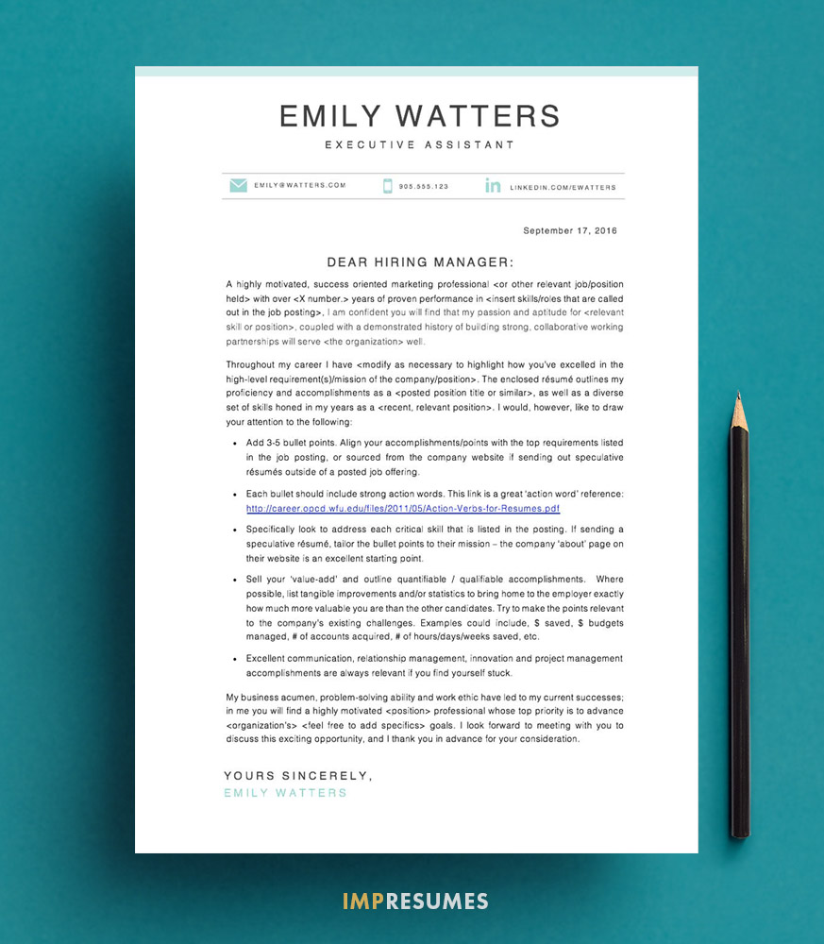
You’ll notice that today’s cover letter format differs slightly from the letter style we initially learned in grade school. We live in a digital world now, after all. Writing the recipient’s mailing address is no longer required unless you’re physically mailing the letter (they already know where they are). Nor is it necessary to include your own mailing address – again, unless you expect them to physically mail you something.

Stick To A Winning, 3-Part Formula

Part 1. Your Intro paragraph
This is where you briefly introduce yourself and mention the job you’re applying for. If you come recommended by someone in the company, this is the place to mention it. Introduce the key reasons you are their preferred candidate, referring back to the job posting.
An example:
I have closely followed Company X’s growth over the last several years, and so I was pleased to learn of the Executive Administrator opening within the Marketing department. Intrigued and excited by the prospect of joining such a dynamic, industry-leading company, I am certain that my many years of experience as an administrative professional coupled with my commitment, discretion and high level of enthusiasm will serve your team well.

Part 2. Show and Tell
Here’s where you show how you’ve previously excelled in the job posting’s most important requirements. Remember: it’s never about what you want out of the position, it’s about how they will benefit by hiring you.
Use bullet points. Bullets are preferable to large paragraphs as they break up huge amounts of text into digestible pieces, making your letter easier to read and quickly digest.
Each bullet should include strong action words. Specifically look to address each critical skill that is listed in the posting. If you’re sending a speculative résumé and there’s no actual job posting to refer to, tailor your bullet points to their mission – the company ‘about’ page on their website is an excellent starting point.
Sell your value and list your accomplishments. Where possible, list tangible improvements and/or statistics to help your future employer really see how you’re more valuable than the other candidates. Make your points and metrics relevant to their existing challenges.
Examples could include, $ saved, $ budgets managed, # of accounts acquired, % of hours/days/weeks saved through process improvements, etc.
Excellent communication, relationship management, innovation, workflow optimization and project management skills are always relevant if you’re stuck.
An example:
Excelling in the end-to-end management of large-scale conferences and fundraising events, I constantly strive to introduce innovative ways to grow the organization and increase revenue. In one year alone, I increased Company X’s fundraising income by more than 400%, while attracting 3 new board members and more than 50 new volunteers.

Part 3. End On A High Note
Take this opportunity to summarize why they should hire you. And ‘assume the sale’ – Write your closing as though you’re guaranteed an interview.
An example:
My business acumen, problem-solving ability and work ethic have led to my current successes; in me, you will find a highly motivated marketing professional whose top priority is to advance Company X’s growth goals. I look forward to meeting with you to discuss this exciting opportunity, and I thank you in advance for your consideration.

Follow Up
Your job hunt doesn’t end after you submit the resume. I encourage you to follow-up by email or telephone within a week of submitting your resume if you haven’t heard anything.
Reaching out to your interviewer is a win-win situation. If they haven’t yet short-listed the candidates, you’ll be front of mind when they get down to it. And if you’re not moved forward for an interview (doubtful, given your kick-ass cover letter writing skills), use the opportunity to a) change their mind and b) know for sure so you can stop wondering and focus on the next opportunity.
Don’t start from scratch – download this cover letter example and start with the same template I give to all of my resume clients

