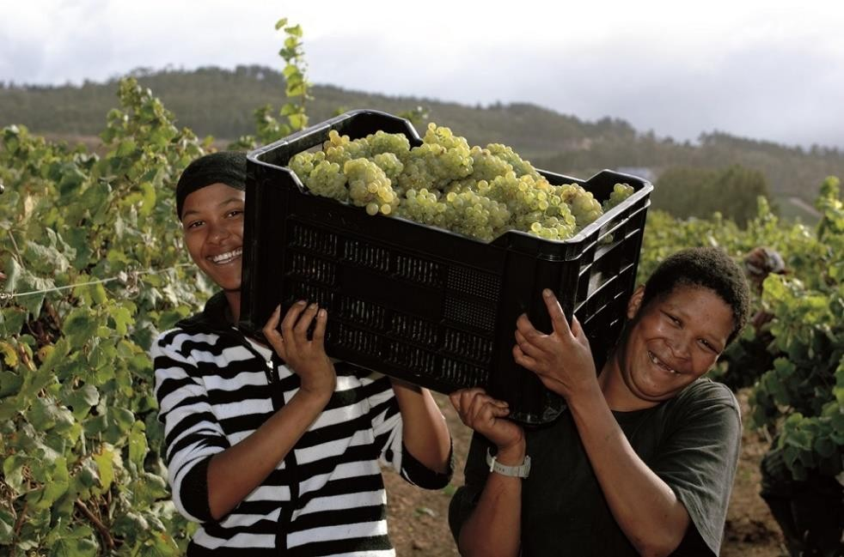

Monitoring and Evaluation Officer

Fairtrade Africa

04.03.2020

Fairtrade Africa (FTA) is the umbrella network organization representing Fairtrade certified producers and workers in Africa. It has four (4) regional networks – Eastern Africa; Southern Africa; West Africa; and Middle East and North Africa. Established in 2005, FTA aims to effectively represent producers and workers within the International Fairtrade System and provide services to them that contribute to the improvement of their livelihoods. The FTA Board directs policy and strategic development of the organization.

FAIRTRADE AFRICA PURPOSE: To improve the socio- economic conditions of African producers through increased access to better trading conditions.

TEAM: Southern Africa Network (SAN) LOCATION: Blantyre, Malawi REPORTING LINES:
Post holder reports to: Head of Region – SAN

Staff reporting to this post: None

BUDGET RESPONSIBILITY: Yes

MAIN PURPOSE OF THE JOB:
Ensure the setting up and implementation of comprehensive monitoring and evaluation systems that facilitate effective planning, implementation, development and performance evaluation and accountability of FTA support services in the Southern Africa Network Region -SAN

Programme Support

- Develop an annual SAN regional specific MEL Plan, update as relevant and review its progress periodically.

- Lead the development and intermittent review of the SAN regional MEL framework and support its implementation.
- Work with the project managers to ensure full understanding of the donor/funder M&E reports requirements and support compliance.
- Review project specific reports to ensure that they adequately respond to the project approved indicators.
- Collate the stakeholder and partners feedback on programmes, develop a report and share it as appropriate.
- Provide technical leadership to the process of collecting, analysis; internal and external dissemination (as appropriate) of relevant performance data
- Build the capacity of program staff on MEL

Coordinate Monitoring Evaluation and research processes

- Provide technical backstopping to all monitoring, evaluation and research processes in the region in consultation with the Monitoring, evaluation and Learning Manager
- Support and (where necessary, lead) the development of ToRs for all evaluation and research activities in the region
- Play a leading role in the review of completed evaluations and researches and ensure that they meet the minimum standards of quality before recommending them for signoff to the MEL manager.
- Advise and recommend tools and strategies to improve project tracking
- Suggest ways to facilitate data collection, analysis and validation
- Analyse changes and patterns in data and performance reports
- Support (and when required, lead) any global MEL initiatives/third party evaluations/research in the region in consultation with the MEL manager.

Strengthen learning

- Identify the top-level recommendations from research conducted in the region and share with staff and relevant stakeholders
- Identify ways and means of sharing the data and information on MEL activities with Fairtrade producers
- In conjunction with the Head of Region and the MEL manager, coordinate reflection sessions with staff to identify what worked and areas of improvement
- Coordinate the process of documenting best practices and case studies from the region.
- Coordinate the process of compiling the regional quarterly report.

Data and knowledge management

- Establish a filing system for all the MEL related documents at the regional level in consultation with the MEL manager and ensure other staff can access.
- Ensure that all the staff in the region can access corporate systems and are supported when they have challenges
- Provide up to date monitoring data and analysis thereof as and when required and ensure data queries are addressed in an accurate and timely manner
- Identify ways and means of sharing the data and information on MEL activities with Fairtrade producers
- Support the Head of Region in Data Management at producer and local level.

Building Relationships

- Map out and develop a database of relevant M&E stakeholders (including CSO) and update the list at least once annually.
- Identify and propose institutions for potential partnerships with FTA on research.
- Participate in relevant MEL networks

Minimum Academic Requirement
Bachelor’s Degree in Development studies, statistics, social science, development or other related fields

Other Specialist qualification (Desired)
  - Knowledge and understanding of the Fairtrade system
  - Certificate in Research methods/M&E
  - Project Management Certificate

Minimum Years of Relevant Experience
At least 3 years’ working experience in a similar position

Knowledge of Systems and Procedures
  - Knowledge in qualitative and quantitative research methodologies
  - Knowledge in mobile data collection tools
  - Knowledge in concepts of Monitoring and Evaluation

  - Knowledge in statistical tools for data analysis
  - Proficient in using MS Office applications especially Excel
  - Knowledge in program and project monitoring and evaluation
  - Ability to drive innovation and learning
  - Presentation, training and facilitation skills

Competencies
  - Excellent Analytical Skills
  - Excellent Interpersonal Skills
  - Excellent Negotiation Skills
  - Excellent Communication and reporting Skills
  - Supportive and versatile
  - Results oriented and focused
  - Respectful and a person with integrity

Communication demands and Competencies
  - Excellent written and spoken communication skills
  - Fluent in English

This job description is intended as a guide and should not be viewed as an inflexible specification as it may be varied from time to time based on discussions with the post holder and the line manager. The post holder will be expected to work to agreed objectives, which should facilitate achievements of key responsibilities in accordance with the Performance Review Process

APPLICATION DEADLINE: 25th MARCH 2020

Interested candidates must send a motivation letter highlighting your suitability to the role and a CV in Word format to annelie@maraisbutton.co.za

This post is restricted to Malawian Nationals only.

Contact will only be made with shortlisted candidates.

